6
Improving
Introduction
Some things can be taught or learned from a book, other things can only be learned by experience. 3D printing is both of these things. I hope you've learned a thing or two from reading this book so far, and I really hope you've had a chance to try some of these things out for yourself as well.

3d printing is also new (at least for most people) and so most of the knowledge is still making its way out into the world in published form. That's not to say that there isn't a lot of information available, but it hasn't evolved into the sort of canonical textbook form you might pick up and read to know everything about it.

So reading a book like this, or a website like reprap.org or even buying a nice new printer and following the instructions will only get you started in this endeavor, and its important to know that the first work you do is likely to be your worst. I don't say this to discourage you but rather to encourage you to keep going beyond this point, because as you spend more time working with the tools the quality of the things you produce will grow, even if it doesn't seem that way to you at the time (and believe me, I can relate to that feeling).

This section of the book includes a number of ways you can cultivate your 3D printing skills. These are things that have worked for me over the years and I offer them as a starting point. Some of these may not work for you, and there certainly are other methods not covered here so if something doesn't work try another. If you've made it this far in this book you're clearly interested in the subject, so if nothing else find ways to push through the frustration or disappointment that comes with learning to do something new, especially something where so much of the territory is yet to be discovered.

Keep a journal
As you've probably come to realize by now, while the field of 3D printing is moving fast the process moves slow. This means that the cycle of performance-feedback-revision is measured in hours or days, and it's easy to loose track of exactly what you've been doing, especially if you're spreading the work out over weeks or months or years. Keeping a journal of your work reduces the chances of making the same mistake twice, and over time allows you to see patterns that span time-frames we humans are less equipped to hold in our heads.

A journal doesn't have to take a specific format, it can be a traditional journal with an entry for each work session, or a blog, a series of videos or just a directory of timestamped photographs but what it key is that the entries capture what changes you've made and what the outcome of those changes are. Capturing the chronology is key because it's easy to forget what order things were in when you captured the information, especially a year later. Images are very helpful because a lot of the problems you encounter working with 3D printing are hard to describe in words, or if there are words for specific phenomenon you might not know what they are, so having a photo or video you can share with others can help identify known problems that would otherwise be obscured through language. A electronic journal capable of capturing textual information as well has the advantage of being searchable, which can be helpful when a problem recurs that you know you've solved in the past. The most important thing is that maintaining the journal is easy enough that you do it consistently.

When I built my first printer I tried to maintain a very structured journal of the process in the form of a blog. I took photos of every step in the assembly and wrote down all of the operations and my observations of the output. This quickly became exhausting, and when things didn't go together well or didn't work once assembled, the frustration consumed all my energy and I didn't have enough left to carry out the journaling process so the whole thing fell into a black hole. I did keep taking pictures though, and more-or-less by luck or coincidence those photos were timestamped and stored for me automatically on a social network site. This allowed me to go back and view a time-line of my progress with almost no effort on my part, and while more information would have been helpful, this option allowed me to continue the work without loosing the history I would have otherwise lost if a more manual journaling process was the only option.

What I took away from this is the value of having a time-line of my work on this project and I while I didn't change the way I casually cataloged this information, I did make an effort to write down more when I started work on solving a particular problem or trying to improve my output in a specific way.
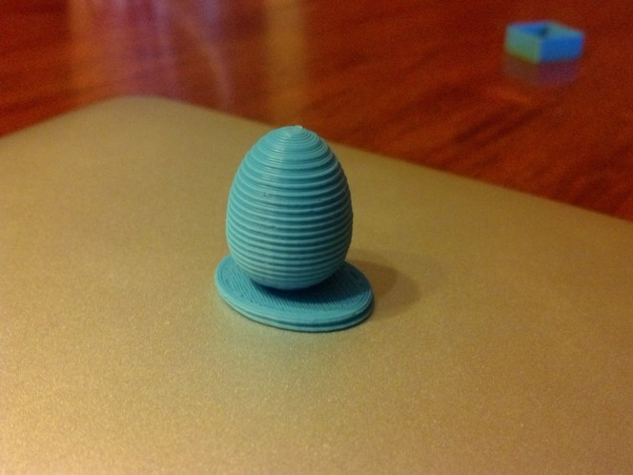Illustration 1: The ribbed pattern on this egg is not present in the model but an error in the printing process.

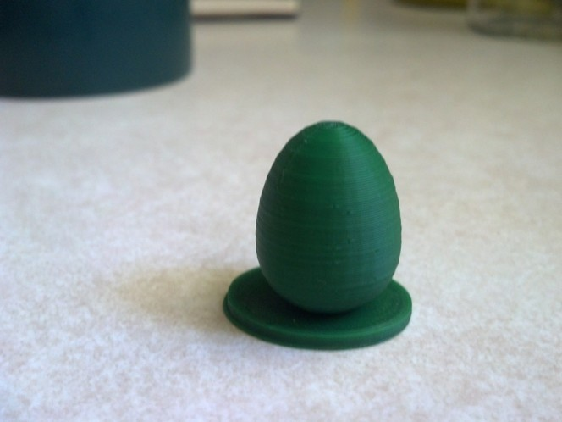Illustration 2: This is the same model as show above, but printed after a problem in the printer's Z axis was found and eliminated.

Study other's work
One of the greatest things about the rise of desktop 3D printing is that almost all of it has happened on-line. This means that almost everyone contributing to the development and improvement of these machines has at one point or another shared their work and thus there is a vast and accessible body of work in this field that can be studied to improve your own skills and creations.

With the wider availability of off-the-shelf printers most peoples first experience with 3D printing will be printing something designed by someone else. This is a great way to see how items designed for 3D printing are put together, and we've discussed some of these processes and concerns earlier in this book. What's less obvious is how studying how other people have solved problems can be applied to your own designs, and this is of particular importance to people who are designing parts of an engineering nature as many engineering problems have solutions that go far back before the history of 3D printing.

I have a number of books that are nothing more than catalogs of various mechanisms that show different ways to move physical objects around. Cranks, gears, cams, etc. have all been extensively engineering throughout history and much of this information is available either on-line or in old dusty books in your local public library. What's particularly cool about these old books is that a lot of them have mechanisms that are not seen very often anymore because they have been replaced with less expensive electric or electronic alternatives more suitable to mass production, but with the ability to create complex mechanical parts on your desk in the form of a 3D printer these old mechanisms can be used to solve modern problems in a cost-effective (or at least more fun to watch) way.
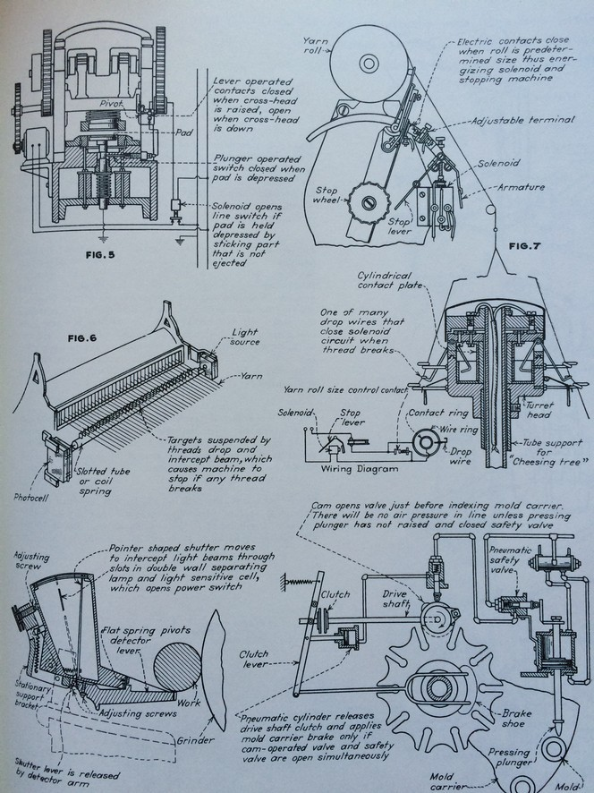Illustration 3: This is a page from a book I got at a garage sale showing just a sample of all the interesting and amazing mechanisms you can find to solve problems in your designs or inspire entirely new ones!

Aside from the use as reference material to solve problems in existing designs, I've found just flipping through these books can inspire new ideas as well, and I've designed several devices simply as an excuse to put a clever design I came across in a book to use. You may have noticed that many extruders use v-shaped “herringbone” gears, these gears are not very common in common contemporary use because they are difficult to manufacture using common mass-production techniques, but they are very good at delivering force with precision, and since it's not much harder for a 3D printer to print these gears instead of the more familiar straight-cut gear, you see them used in a lot of things designed to be printed. This is an example of using a part or design that is impractical for common mass-produced goods where the manufacturing cost needs to be justified by the selling price of the item makes sense when you have the means of producing complex parts inexpensively on-hand.
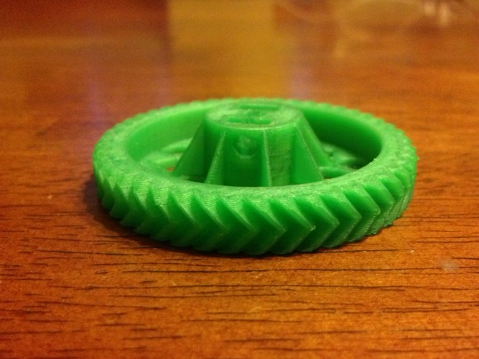Illustration 4: The ubiquitous herringbone gear pattern found on many 3D printed parts is difficult to machine using traditional manufacturing techniques.

In fact, the availability of 3D printing has caused something of a resurgence in mechanical design, and some of the purely-mechanical devices and machines that have gone by the wayside over the last century are enjoying a comeback now that it is possible to produce the parts used by these machines with access to a full machine shop (and the associated skills and materials necessary to use one).

Know your printer
Looking at it from the perspective of a designer, the capabilities you expect from the 3D printer that will render your work seem straightforward; a combination of maximum length, width, height; perhaps a limited set of materials, etc. but in reality each printer is different, especially when it comes to Reprap printers that are built as one-of-a-kind, and being familiar with the strengths and weaknesses of the printer you'll be using can inform your design choices in a way that maximize the quality which the hardware is capable of.

Here's a simple example: A Mendel-style Reprap printer moves the bed back and forth along the Y axis. This applies lateral force to the model as it is printed, which means that while the Mendel may be capable of printing objects 200mm tall, tall thin models are more likely to loose adhesion to the bed on this style of printer verses say an Ultimaker which moves the bed in the Z axis.

There are many subtle ways in which a printer's capability can vary and often these are not obvious from the basic specifications. The best way to learn about what the printer does best (and worst) is to print some models and observe carefully. This is an area where a journal with photographs comes in handy, because over time you'll start to notice patterns in the errors that occur in your output over time, as well as what is in common between prints that turn out particularly well.

<photo sequence showing an error that became more apparent over a series of prints spaced out over a period of time>

As you learn more about a particular printer you can adjust your designs to work within this “envelope” and the result will be a higher percentage of successful prints, along with an overall improvement in average quality. If you have access to more than one printer you can start building up this information in terms of what printer is most suitable for a particular project, and you'll even start to get an instinct about this when discussing new designs and ideas with others.

You can then use this knowledge to understand “why” each printer exhibits these traits, and you'll gain the ability to predict how a printer will perform at certain tasks by examining the design choices made by the machines engineers. This is very helpful when considering a new printer (for yourself or others) as well as knowing how you might address these problems yourself as described in the next section.

Modify your printer
The original goal of the Reprap project was to create a machine capable of creating copies of itself. While we've yet to see a Reprap that is 100% capable of this, most designs are able to produce the majority of their own parts, which gives them the ability to produce better parts as well.

The beauty of the open-nature of the Reprap project is that it leverages the minds of hackers around the world to continually produce improvements, and as the machines are capable of printing their own parts. Until now if you had a machine and a better part was made for it you had to have it shipped to you physically whereas with the Reprap an improved part can be delivered to you across the Internet almost instantaneously, with almost no cost in terms of time, fuel or labor and can be produced locally by the very machine that the part will be used in. This means that improvements spread quickly, almost as quickly as improvements in software, which is only possible due to the open-source nature of the Reprap hardware.

It's worth mentioning that even if your printer wasn't brought into this world as a Reprap that is can still benefit from this capability, to the degree that several commercial 3D printing companies recommend that the first prints a new owner makes are parts for the machine that they have improved since the date of manufacture.
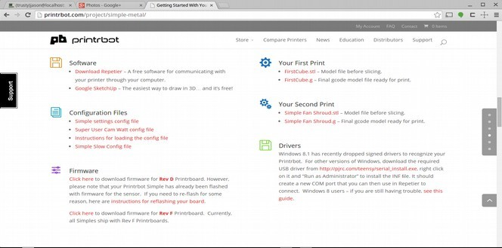Illustration 5: The second thing Printrbot recommends new owners print is a fan shroud to improve print quality.

While the ability for a designer or manufacturer to send improved parts to customers electronically is revolutionary, it's not even the coolest part. During the design of a machine engineers make compromises to improve performance in one area that diminish performance in another. These choices are guided by what the company sees as the primary market for the machine and are not taken lightly, but the result can be a compromise that is good for the majority but might not be exactly right for your personal application, or perhaps one application you have in mind at a certain time.

With the Reprap you can “undo” these compromises, and you can make new ones yourself in order to bring your machine's capabilities more in-line with the work you intend to use it for. For example, a common trade-off is quality-vs-speed. To some degree you can make changes in the control software of the printer to trade higher print speed for lower quality, but there are limits to this approach. With the Reprap you can take this further and design & print parts that alter the machine in a way that goes beyond what could be done with software alone. In fact you could design changes that limit a printer in ways that would make it completely unappealing to the mass market but stellar for your specialized application, which is something that would never work for a machine that had to use one design to satisfy the size of market needed to sustain the mass-production process.

Remember those two eggs discussed above? The journaling process helped me see a pattern to the error across multiple models, and led me to a few theories as to what the cause was. I experimented with several software settings to see if I could eliminate the problem but it became apparent that the whole problem wasn't contained within the software configuration. A closer look at the error indicated that the shape of the threaded rod used in the Z axis of the printer was being impressed upon the part, but what could be done about it? Before I could answer that, I had to understand how it was happening.
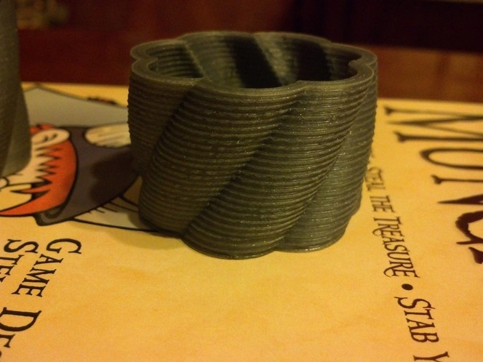Illustration 6: It's not obvious when looking at a print with a complex shape, but seen on this circular part the similarity between the ridges on the outside and the thread of the Z axis rod becomes more noticeable.

In my case the cause was that the Z axis rod was the same diameter as the smooth rod that guides the Z axis. This is a problem because threaded rod is often imperfect, and the smooth rod used to overcome these imperfections, being the same diameter, wasn't strong enough to resist being moved by the bends in the threaded rod. So I tried a number of new parts designed to overcome this.
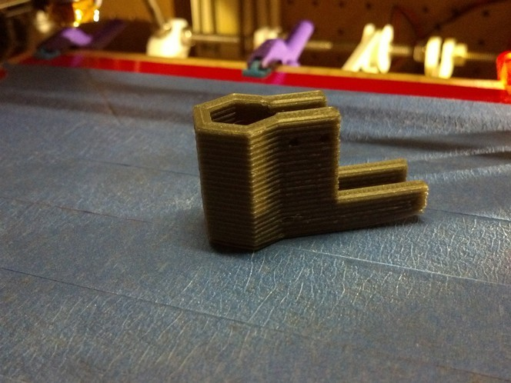Illustration 7: Once the source of the error was found, several modifications were attempted to eliminate it. This part allows the threaded rod to move laterally without "telegraphing" the movement to the rest of the axis.
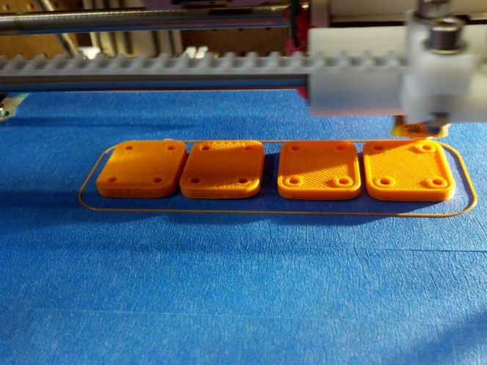Illustration 8: The first modification didn't eliminate the error so another approach was found that replaces the large threaded rod with a smaller diameter one that can't push the smooth rod around. This requires smaller clamps to hold the threaded rod, seen in-progress here.
This required several lengthy experiments that took place over a number of weeks (another example of where a good journal was critical) but eventually I found a combination of modifications that completely eliminated this error from my prints.
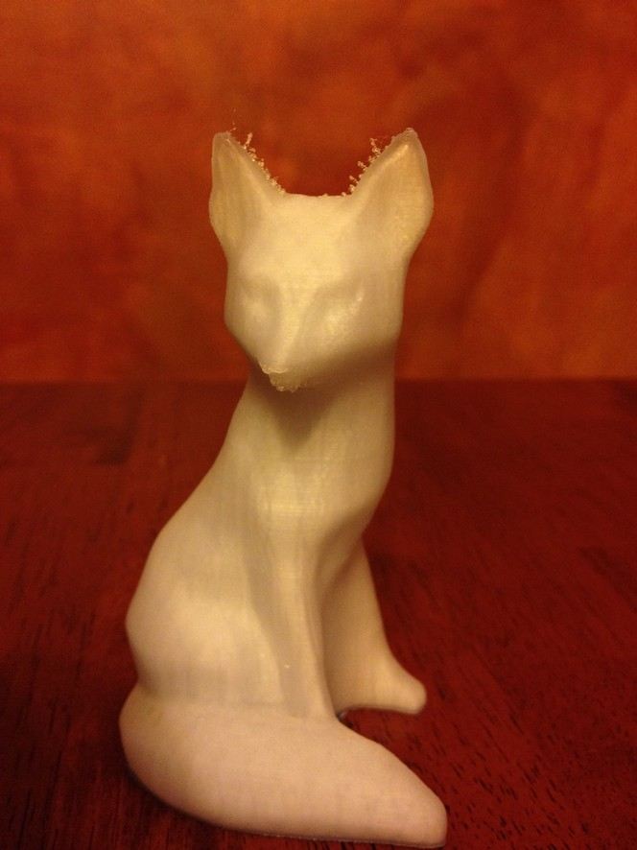Illustration 9: This fox shows just how much difference a small change can make, once you know what to change and and find the best solution (of course this reveals a new problem to solve next, if you look closely at the ears).

Over time, I was able to further improve the parts I used to eliminate this error to overcome limitations of their design or address other problems that became more visible now that the average quality of my prints improved.

This might sound complicated or that it requires engineering experience, etc. but it's really just a matter of observing your machine and taking good notes. Over time you'll observe behaviors of the machine that result in effects in the output that you find desirable or undesirable, and you can use the design skills you've learned already to design parts to enhance or counteract these effects. If you have a printer based on an open-source design you have a leg-up in this process because you can simply download the printer's parts and start modifying the original designs, but even if you start with a non-open machine nothing stops you from printing parts to modify and improve it (always remember that the first Reprap parts were printed on closed-source commercial machines).

Experiment
When you have access to a 3D printer it's hard not to let you mind run free with all of the new things you're going to make, but it's important to dedicate some of the machine's time to printing things that are not “committed” to practical use.

One thing to get comfortable with is the idea that you're going to print a lot of things that are not going to turn out perfect the first time. This might sound obvious, but it can get frustrating, and I've known several people who have lost interest because they are unable to get the results they want from their printer. If you look at the printer as a production machine I can see how you'd arrive at this place, but I think it's still far to early in the evolution of desktop manufacturing to treat any printer available today this way.

Instead I recommend allocating a percentage of machine time to pure experimentation. This includes printing parts designed to test the limits of the machine, or the limits of your design capability. It also includes testing modifications and improvements like the ones described in the previous section. Whatever you do, consider all output from this experimental time to be fodder for recycling and don't try to produce things that are needed outside of the experimental process itself. By deliberately allocating time to experiment you remove all consequence (both real and imagined) from producing unusable output, and this is an important thing to do. If you don't you'll eventually find yourself in a place where no matter what you do you can't get the printer to print well and you'll be ready to give up.

I speak from experience here, so don't take this lightly. Desktop 3D printing is still in the very early stages of development and trying to rush through that will result in compromises that will last a very long time. Many people compare the 3D printer to the personal computer and I think this is apt, however I disagree with the idea that the current generation printers are at a stage analogous to the Apple II or Commodore 64 era of personal computing. I believe we are still at the ALTAIR stage (Google it ) which means that the future is best served by getting smart and creative people involved with 3D printing who genuinely love trying new things and learning from failure.

By trying to make 3D printing “perfect” in its current form we run the risk of finding something better through the natural evolutionary process enjoyed by the Reprap up until this point; in fact as we discussed near the beginning of the book there are many new and interesting Reprap designs that are a complete departure from the original machines, but if you look at what is being offered by many commercial (and especially manufacturers of non-open-source machines) you'll see that the designs are all based on the previous generation of machines. To continue with the personal computer analogy, this similar to how many computers retain the architecture of the first IBM PC today, and the limitations and constraints that go along with it.

By keeping 3D printing “wild” we can continue to enjoy an environment where machines can get better year-over-year (or month-over-month) based on the creativity and skill of a million minds working together instead of against each-other. By this I don't mean to say there's no place for reliable machines that “just work”, but I don't believe that we're at a point where the existing “best practice” designs can be made into a consumer-grade product. So by instilling the experimental attitude in everyone who works with these machines, we avoid the need to make them “foolproof” which leads to a more limited, less creative and honestly more frustrating and less fun experience.

